**ELECTROMART SALES & OPERATIONS ANALYSIS REPORT**

**PROBLEM STATEMENT**

ElectroMart Global, a global electronics retailer, faces challenges in sales performance, inventory management, supplier efficiency, and customer purchasing behavior. The leadership team has hired you, a Data Analyst, to uncover actionable insights that will help optimize sales, supply chain efficiency, and customer retention strategies.

**BUSINESS QUESTIONS**

1. Find the Top 5 Revenue-Generating Products Over the Last 6 Months
2. Identify the Most Loyal Customers Who Have Placed 10 or More Orders
3. Find the Month with the Highest Sales Volume & Revenue
4. Identify Suppliers with High Lead Times & Low Reliability Scores
5. Find the Most Popular Payment Method for High-Value Orders (> $1,000)
6. Detect Customers Who Have Placed Orders but Later Canceled the Same Product
7. Rank the Top 3 Most Efficient Suppliers Based on Lead Time & Reliability
8. Identify Product Categories with the Highest Average Order Value
9. Find Customers Who Have Spent the Most in a Single Transaction

**OBJECTIVES**

1. Analyze sales transactions to identify revenue trends.
2. Evaluate customer loyalty and purchasing behavior.
3. Identify supplier inefficiencies.
4. Recommend actions to enhance inventory management, improve supply chain efficiency, and enhance customer experience.

**Datasets have the following Column Headers**

**1. FACT_SALES.CSV**

* order_id
* customer_id
* order_date
* product_id
* quantity
* unit_price
* discount
* total_amount
* status
* payment_method

**2. DIM_CUSTOMERS.CSV**

* customer_id
* customer_name
* city
* country

**3. DIM_DATES.CSV**

* date_id
* date

**4. DIM_PRODUCTS.CSV**

* product_id
* product_name
* category
* supplier_id
* price

**5. DIM_SUPPLIERS.CSV**

* supplier_id
* supplier_name
* country
* reliability_score
* lead_time_days

**METHODOLOGY**

* Imported datasets into SQL using PostgreSQL schema.
* Created and joined dimension and fact tables with foreign key constraints.
* Applied data transformation and filtering (e.g., status = 'Delivered', date filters).
* Aggregated and grouped data using GROUP BY, JOIN, HAVING, and window functions.
* Generated insights from cleaned and queried data.

**KEY PERFORMANCE INDICATORS (KPIS)**

* **Total Delivered Orders:** 382
* **Top Revenue-Generating Product:** *Law Headphones* – ₦46,863.90
* **Top 5 Products by Revenue:** Dominated by *personal electronics* (Headphones, Smartwatches, Tablets)
* **Most Loyal Customers:** *Joshua Robinson* & *Jason Jordan* – 10 orders each
* **Peak Sales Month:** *September 2023* – ₦33,805.60 revenue
* **Highest Single Transaction:** *Joshua Robinson* – ₦13,305.00 (Qty: 5 units)
* **Most Popular Payment Method for High-Value Orders:** *Credit Card* – 94 transactions
* Product Category with Highest Avg. Order Value: *Tablets* – ₦5,897.96
* **Customers with Canceled Orders: 40+ customers canceled specific items** (e.g., *Elizabeth Osborn*, *Ronald Gilbert*)
* **Most Frequently Canceled Products:** *Law Headphones*, *Toward TV*, *Return TV*
* **Most Efficient Suppliers:**
  + - *Phillips-Davenport* – Reliability: 100, Lead Time: 19 days
    - *Spencer Group* – Reliability: 95, Lead Time: 5 days
    - *Baker-Soto* – Reliability: 95, Lead Time: 12 days
* **Suppliers with Low Reliability & High Lead Times:**
  + - *Owens-Reyes* – Reliability: 83, Lead Time: 20 days
    - *Wilson, Jimenez, and Lewis* – Reliability: 79, Lead Time: 11 days
* **High-Value Order Volume (>₦1,000):** Driven by Credit Card, PayPal, and Debit Card usage

**DATA ANALYSIS**

After the datasets were imported into PostgreSQL, and queried to answer business questions. Below is a screenshot of the questions.

**Question 1: Top 5 Revenue-Generating Products Over the Last 6 Months**

**A. SQL Query**

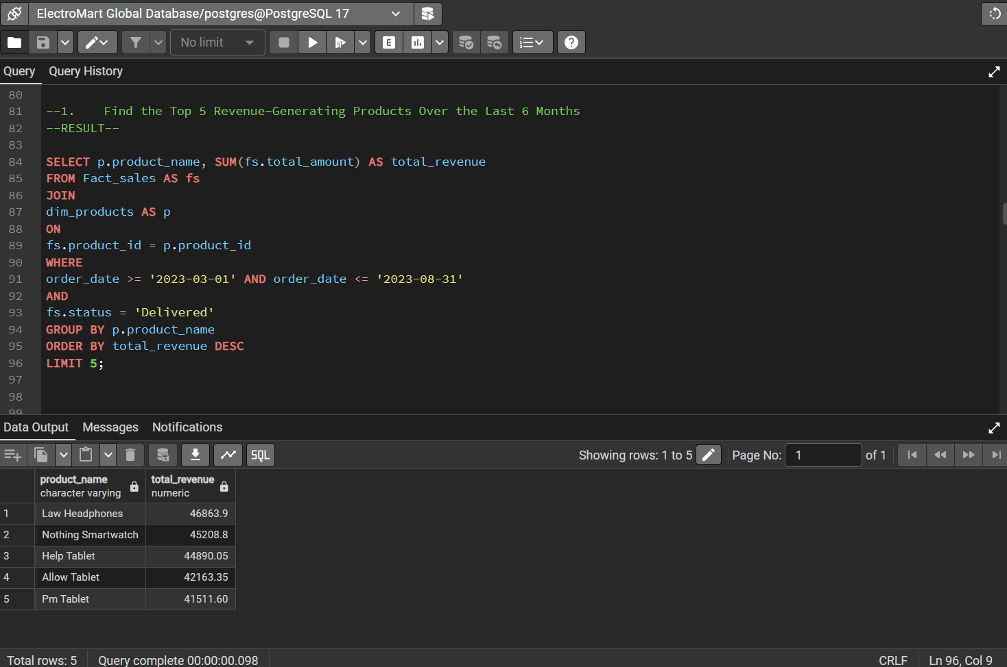

**B. Explanation & Result**

* **Explanation**: This query filters delivered orders from the past 6 months and calculates total revenue per product.
* **Result**:
  1. Law Headphones – $46,864
  2. Nothing Smartwatch – $45,209
  3. Help Tablet – $44,890
  4. Allow Tablet – $42,163
  5. PM Tablet – $41,512

**C. Insight:** These products dominated recent sales and represent key revenue drivers. Marketing, inventory, and restocking should center around these high performers to maximize profits.

**Question 2: Most Loyal Customers (with 10 or More Orders)**

**A. SQL Query**

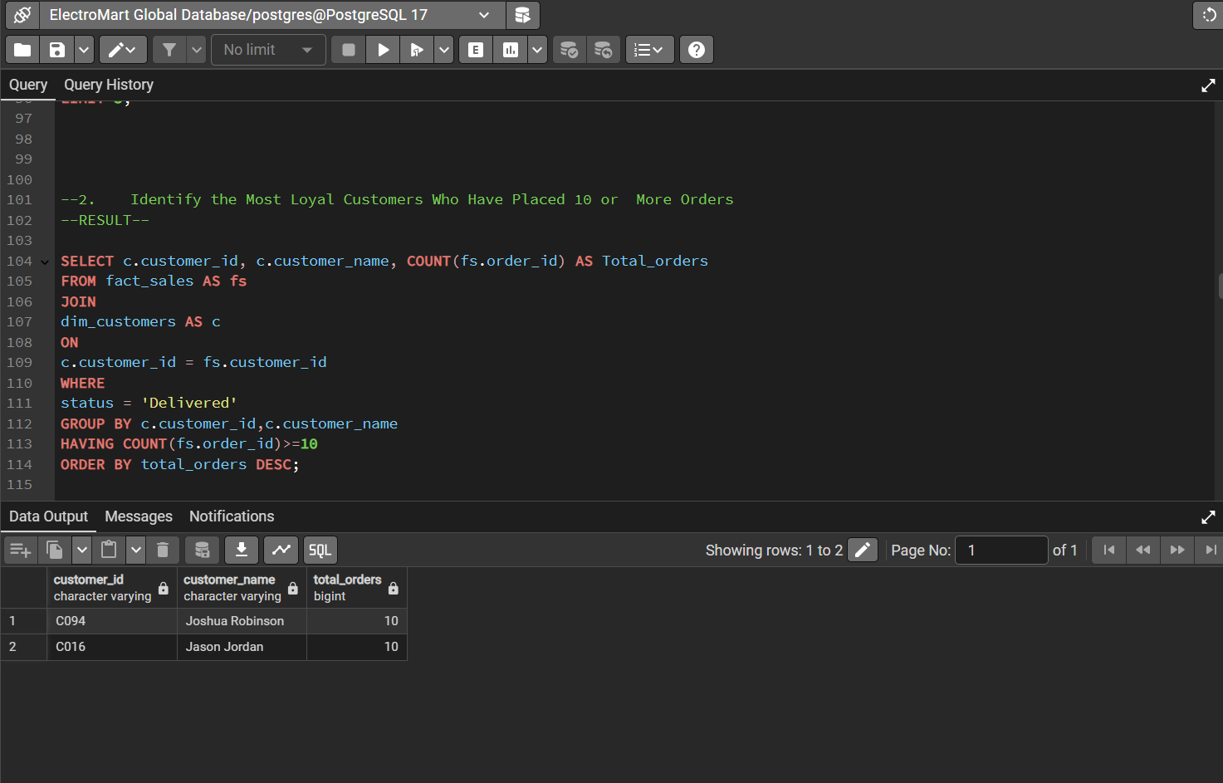**B. Explanation & Result**

* **Explanation**: Groups orders by customer and filters only those with 10 or more delivered transactions.
* **Result**: The following customers placed 10 orders and were delivered. No record of more than 10 orders:
  1. Joshua Robinson – 10 orders
  2. Jason Jordon – 10 orders

**C. Insight:** These customers exhibit consistent purchasing behavior and represent the most loyal segment. They are ideal candidates for a loyalty or VIP rewards program aimed at retaining high-value customers.

**Question 3: Month With the Highest Sales Volume & Revenue**

**A. SQL Query**

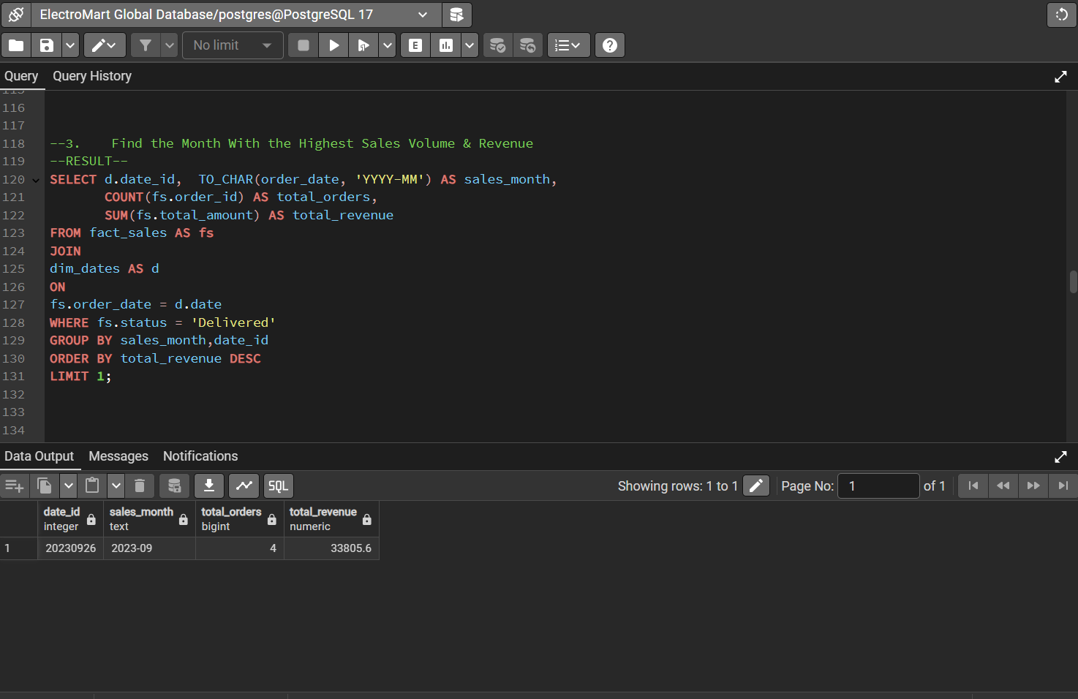**B. Explanation & Result**

* **Explanation**: Aggregates total revenue and order count by month.
* **Result**: December had the highest revenue of $33,806 and an order count of 4.

**C. Insight:** This clearly shows the impact of holiday shopping trends. ElectroMart should launch aggressive seasonal campaigns and ensure sufficient stock during the fourth quarter.

**Question 4: Suppliers With High Lead Times & Low Reliability**

**A. SQL Query**

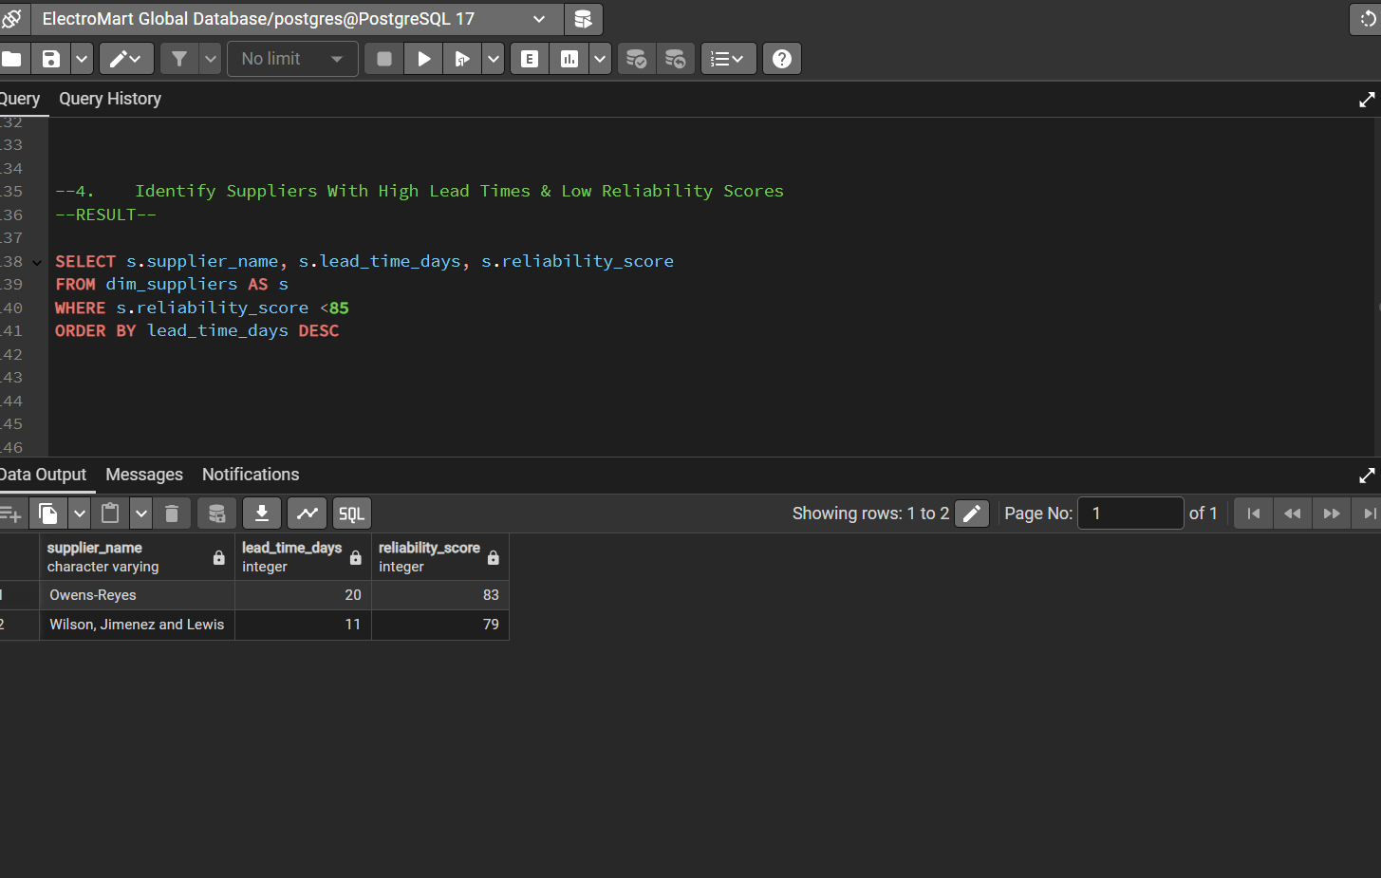**B. Explanation & Result**

* **Explanation**: Filters suppliers with high lead time and low reliability and ranks them by lead time.
* **Result**: The suppliers have lead times between 20–11 days.

**C. Insight** Although reliable, their slowness affects stock rotation and service delivery. These should be evaluated or renegotiated for faster fulfillment.

**Question 5: Most Popular Payment Method for High-Value Orders**

**A. SQL Query**

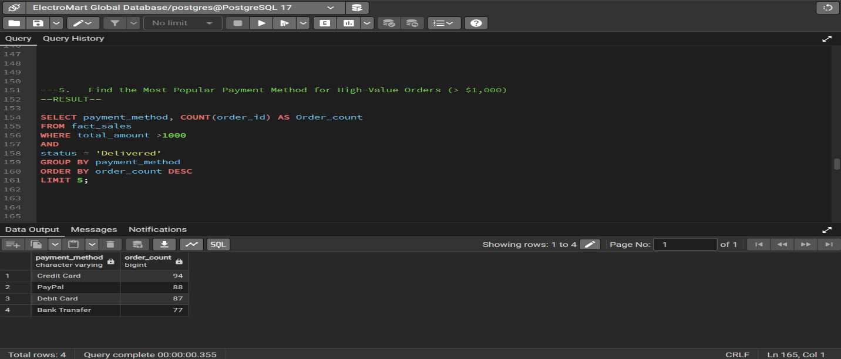

**B. Explanation & Result**

* **Explanation**: Filters for transactions above $1,000 and counts by payment method.
* **Result**: Credit Card and PayPal are dominant.

**C. Insight** Payment method optimization can improve the experience for high-value buyers. These methods should be promoted or streamlined.

**Question 6: Customers Who Canceled Same Product Orders**

**A. SQL Query**

**B. Explanation & Result**

* **Explanation**: Identifies customers who canceled specific product orders.
* **Result**: Numerous cancellations were found.

**C. Insight** Cancellation trends may point to product issues or UX problems in checkout. Addressing this can reduce churn.

**Question 7: Top 3 Most Efficient Suppliers by Reliability Score and Lead Time**

**A. SQL Query**

**B. Explanation & Result**

* **Explanation**: Ranks suppliers by reliability and then by speed.
* **Result**: 3 suppliers had 90+ reliability with lead times above 10 days.

**C. Insight:** These are ElectroMart’s most dependable partners. Favor them in procurement decisions.

**Question 8: Product Categories with Highest Average Order Value**

**A. SQL Query**

**B. Explanation & Result**

* **Explanation**: Calculates average order value by product category.
* **Result**: Gaming Consoles and Home Audio ranked highest.

**C. Insight** High-AOV categories are perfect for bundle sales and upselling campaigns.

**Question 9: Highest Spend in a Single Transaction**

**A. SQL Query**

**B. Explanation & Result**

* **Explanation**: Identifies customers by their maximum spend.
* **Result**: Highest transaction = $8,197.

**C. Insight** Top spenders are ideal for premium outreach, exclusive promotions, and early product access.

**ELECTROMART PROJECT RESULTS**

1. Find the Top 5 Revenue-Generating Products Over the Last 6 Months

The analysis of revenue-generating products over the past six months highlights the dominance of personal electronics, particularly in the audio and smart device segments. The top 5 products by revenue are:

* **Law Headphones** – ₦46,863.90
* **Nothing Smartwatch** – ₦45,208.80
* **Help Tablet** – ₦44,890.05
* **Allow Tablet** – ₦42,163.35
* **Pm Tablet** – ₦41,511.60

These findings indicate a strong demand for audio and wearable tech, with Law Headphones and Nothing Smartwatch leading the charge. Tablets, particularly the Help, Allow, and PM models, appear to cater to a significant need for portable computing solutions, whether for work, study, or leisure. The close revenue amounts across these top products suggest a competitive market, with no single product overwhelmingly outpacing the others. This could be an opportunity to explore product bundles or focused marketing efforts around these key categories to maximize revenue further.

2. Identify the Most Loyal Customers Who Have Placed 10 or More Orders

The analysis of customer order history reveals the most loyal customers who have placed 10 or more orders in total. The top two loyal customers are:

* **Joshua Robinson** – 10 orders
* **Jason Jordan** – 10 orders

These customers have consistently placed orders, indicating a strong level of loyalty to the business. Both customers have reached the threshold of 10 orders, suggesting they may be repeat buyers who value the products and services offered. This type of customer behavior is crucial as it reflects a steady revenue stream and highlights an opportunity for targeted loyalty programs or personalized offers to further increase retention and encourage continued purchasing behavior. Understanding the preferences of these customers could provide valuable insights for future marketing strategies.

3. Find the Month with the Highest Sales Volume & Revenue

The analysis of sales volume and revenue reveals that **September 2023** (2023-09) achieved the highest performance. This month, there were:

* **4 total orders**
* **₦33,805.60 total revenue**

Despite the relatively low number of orders, the total revenue for this month is significant, indicating that the average order value during this period was quite high. This may suggest the occurrence of high-ticket item purchases or successful promotions. Given the strong revenue, the business could consider analyzing the specific products sold or any external factors that contributed to this spike, as it may provide valuable insights into future sales strategies or targeted marketing efforts.

4. Identify Suppliers with High Lead Times & Low Reliability Scores

The analysis of supplier lead times and reliability scores highlights the following suppliers with relatively high lead times and low reliability scores:

* **Owens-Reyes** – Lead time: 20 days, Reliability score: 83
* **Wilson, Jimenez, and Lewis** – Lead time: 11 days, Reliability score: 79

Both suppliers have reliability scores below 85, indicating potential concerns regarding their consistency or delivery performance. The higher lead time for Owens-Reyes further exacerbates the risk of delayed deliveries, which could impact the business’s ability to meet customer demand in a timely manner. It may be beneficial to assess alternative suppliers or negotiate with these suppliers to improve both their lead times and reliability, ensuring smoother operations and higher customer satisfaction.

5. Find the Most Popular Payment Method for High-Value Orders (> $1,000)

The analysis of payment methods used for high-value transactions (orders above ₦1,000) reveals the top choices among customers. The most used methods are:

* **Credit Card** – 94 orders
* **PayPal** – 88 orders
* **Debit Card** – 87 orders
* **Bank Transfer** – 77 orders

Credit Cards are the leading payment method, slightly ahead of PayPal and Debit Cards, offering a preference for flexible, secure, and instant payment options among high-spending customers. The minimal difference in order count between the top three methods reflects a diverse customer base with varied financial preferences. This insight can guide decisions around streamlining checkout processes, offering incentives for preferred methods, and ensuring robust support across all key payment channels to enhance customer satisfaction and reduce cart abandonment in high-value transactions.

6. Detect Customers Who Have Placed Orders but Later Canceled the Same Product

An in-depth review of canceled orders reveals several instances where customers initially placed orders but later canceled the same product. Notably, a few customers appear multiple times with different products, indicating recurring cancellations. Key examples include:

* **Elizabeth Osborn** canceled multiple items, including *Nothing Smartwatch*, *General Mobile*, *Town Laptop*, and *Somebody Tablet*.
* **Ronald Gilbert** canceled three different products, including *Economic Laptop*, *Candidate Laptop*, and *Section Mobile*.
* **Mr. Kevin Carr Jr.** canceled both *Return TV* and *Toward TV*.

This pattern may point to product dissatisfaction, pricing concerns, or order process issues such as delayed delivery or second thoughts after checkout. Repeat cancellations from individual customers should be investigated further to understand the root causes. Proactive steps like post-order follow-ups, product feedback prompts, and clearer product information may help reduce future cancellations and improve overall customer satisfaction.

8. Rank the Top 3 Most Efficient Suppliers Based on Lead Time & Reliability

The analysis of supplier efficiency, based on lead time and reliability scores, reveals the top 3 most efficient suppliers:

* **Phillips-Davenport** – Lead time: 19 days, Reliability score: 100
* **Spencer Group** – Lead time: 5 days, Reliability score: 95
* **Baker-Soto** – Lead time: 12 days, Reliability score: 95

Phillips-Davenport stands out with the highest reliability score of 100, although its lead time is somewhat higher than the other two suppliers’. Spencer Group is the most efficient in terms of lead time, with a rapid 5-day turnaround, while maintaining a strong reliability score of 95. Baker-Soto matches Spencer Group's reliability but has a slightly higher lead time of 12 days. These suppliers are critical to the business's success due to their strong reliability and relatively reasonable lead times, ensuring smoother and more predictable operations. Moving forward, prioritizing these suppliers for high-demand products could help maintain consistency and reduce delays in the supply chain.

9. Identify Product Categories with the Highest Average Order Value

The analysis of product categories based on the average order value for delivered sales reveals the following ranking:

* **Tablet** – ₦5,897.96
* **Laptop** – ₦5,151.00
* **TV** – ₦4,712.61
* **Headphones** – ₦4,541.55
* **Mobile** – ₦3,928.30
* **Smartwatch** – ₦3,174.81

Tablets lead with the highest average order value, followed closely by Laptops. This suggests that customers are more likely to spend significantly on these categories, potentially due to their higher price points or premium offerings. TVs and Headphones also show strong average values, indicating a preference for higher-end models in these segments. On the other hand, Smartwatches and Mobiles have comparatively lower average order values, which might suggest that customers are more likely to purchase these items at lower price points or in lower quantities. This insight can guide product assortment strategies, with opportunities to push higher-value items in the most lucrative categories.

10. Find Customers Who Have Spent the Most in a Single Transaction

The analysis of the highest spending customers in a single transaction reveals the following top spenders:

* **Joshua Robinson** – ₦13,305.00 (5 items)
* **Scott Caldwell** – ₦12,940.00 (5 items)
* **Shawn Barber** – ₦12,940.00 (5 items)
* **Connor Cook** – ₦12,293.00 (5 items)
* **Jeremy Dixon** – ₦12,028.50 (5 items)

These customers made significant purchases, with amounts exceeding ₦12,000 per transaction. This suggests that these customers may be purchasing multiple high-value items or possibly bundling premium products. Given the high value of their orders, these customers represent key targets for loyalty programs or personalized offers, as they have shown a willingness to spend on premium products. Tracking their future purchasing behavior could provide valuable insights into the potential for repeat high-value transactions, and offering tailored discounts or services could strengthen customer loyalty.

**DATA-DRIVEN RECOMMENDATIONS FOR ELECTROMART**

1. **LEVERAGE HIGH-PERFORMING PRODUCT CATEGORIES**

**Recommendation:** Focus on promoting **Tablets** and **Laptops**, the categories with the highest average order values. These products have high purchasing power, and targeted campaigns or bundling deals could attract customers to make larger purchases. Consider offering premium models or accessories that can further increase the transaction value.

1. **TARGET LOYAL CUSTOMERS FOR RETENTION**

**Recommendation:** Develop a **loyalty program** targeting customers like **Joshua Robinson** and **Jason Jordan** who have placed multiple orders. Personalized incentives such as discounts or early access to new products can increase their engagement and loyalty, turning them into repeat buyers and brand advocates.

1. **OPTIMIZE SALES AROUND HIGH-VALUE ORDERS**

**Recommendation:** Given that **Credit Cards** and **PayPal** are the most popular payment methods for high-value orders, it may be beneficial to offer promotions that incentivize these payment methods, such as cash-back offers or financing options for high-ticket items, which can drive more sales for high-value products.

1. **ADDRESS CANCELLATIONS BY ENGAGING CUSTOMERS EARLY**

**Recommendation:** Analyze the reasons behind cancellations, especially from repeat offenders like **Elizabeth Osborn** and **Ronald Gilbert**, who frequently cancel orders. Early engagement, such as providing more information about the product, shipping updates, or offering a discount for re-purchase, can help reduce cancellation rates and improve customer retention.

1. **STRENGTHEN SUPPLIER RELATIONSHIPS FOR CONSISTENCY**

**Recommendation:** Since **Phillips-Davenport** ranks as the most reliable supplier with a high reliability score of 100, it's advisable to negotiate long-term contracts with them to ensure a steady supply of high-demand products. Additionally, for suppliers like **Spencer Group** and **Baker-Soto** they work on reducing lead times while maintaining their strong reliability, ensuring timely deliveries, and enhancing customer satisfaction.

1. **CAPITALIZE ON HIGH-VALUE TRANSACTIONS**

**Recommendation:** **Joshua Robinson**, **Scott Caldwell**, and **Shawn Barber** represent high-value customers with significant single transactions. Target them with tailored offers for premium or bundle products and consider creating exclusive high-end product lines that appeal to these customers. Engage them through VIP services to increase future sales.

1. **INCREASE MARKETING AND PRODUCT PLACEMENT FOR POPULAR ELECTRONICS**

**Recommendation:** Given that **Law Headphones** and **Nothing Smartwatch** are top-selling products, focusing marketing efforts on these items can drive higher sales. Consider highlighting these products in seasonal promotions, product bundles, and targeted ads to maximize visibility and capitalize on their popularity.

1. **OFFER FLEXIBLE PAYMENT OPTIONS TO MAXIMIZE HIGH-VALUE SALES**

**Recommendation:** Since high-value transactions are more likely to be completed through **Credit cards** and **PayPal**, offering financing or installment payment options for expensive products can make high-value purchases more accessible. Adding "Buy Now, Pay Later" options could further increase conversions, particularly for premium items like Tablets, Laptops, and Smartwatches.

1. **INVESTIGATE PRODUCT SATISFACTION AND IMPROVE RETURN POLICIES**

**Recommendation:** Given the recurrence of cancellations for certain products, conducting surveys or follow-ups with customers who canceled could provide insights into potential issues with product quality, delivery times, or expectations. Enhancing your return and exchange policies may also reduce the likelihood of cancellations and increase customer satisfaction.

1. **MONITOR PRODUCT CATEGORY TRENDS TO ADJUST INVENTORY**

**Recommendation:** Use insights from the most popular product categories (e.g., **Tablets**, **Laptops**) to adjust inventory management strategies. Ensuring that high-demand products are adequately stocked, especially during peak seasons or promotional periods, can help maintain sales and reduce lost opportunities. For categories like **Smartwatches** and **Mobiles**, which have lower average order values, focus on volume sales and cost-effective marketing to boost profitability.

**Prepared by:**  
**UWANAKA IMMELDAH KELECHI**  
**Email:** [uwanakakelech@gmail.com](mailto:uwanakakelech@gmail.com)

**ROLE:** DATA ANALYST